
EduCheck
Academic Record Validation and Consolidation System
USER'S MANUAL
Web application · Subject Teacher, Class Adviser, School Administrator and Principal
Version 1.0 · October 2026

Contents
1. Introduction 4
1.1 Who uses EduCheck 4
1.2 How a record moves through EduCheck 4
1.3 What you need 5
2. Getting Started (All Users) 6
2.1 Signing in 6
2.2 The welcome guide 7
2.3 Finding your way around 8
2.4 Notifications 8
2.5 Settings 9
2.6 Help & Support 10
2.7 Signing out 11
3. Subject Teacher 12
3.1 Your dashboard 12
3.2 Uploading an e-Class Record 12
3.3 Reading the validation results 14
3.4 Fixing and re-uploading 14
3.5 When your Class Adviser returns a record 15
4. Class Adviser 16
4.1 Your dashboard 16
4.2 Following your section's progress 16
4.3 Reviewing consolidated records 17
4.4 Submitting records for approval 19
4.5 Uploading your own subjects 20
4.6 Records and SF10 20
4.7 Performance analytics 22
5. School Administrator 24
5.1 Your dashboard 24
5.2 School years 24
5.3 Accounts 25
5.4 Sections and teacher assignments 28
5.5 Reviewing and approving submitted records 29
5.6 SF10 school details 30
5.7 Academic analytics 30
5.8 Audit log 31
6. Principal 33
6.1 Your dashboard 33
6.2 Approving accounts 33
6.3 Viewing records and analytics 34
7. Troubleshooting 35

Right-click the table and choose Update Field if page numbers are missing.

1. Introduction
EduCheck is the Academic Record Validation and Consolidation System for public elementary schools. Subject teachers upload the DepEd e-Class Record (ECR) Excel files they already keep. EduCheck reads the grades, checks them against DepEd grading rules, and brings every subject together into each learner's consolidated record. Class Advisers review and submit those records, the School Administrator approves them, and the approved grades flow into the learner's permanent record (SF10-ES).
This manual explains how to use the EduCheck web application. Chapter 2 covers what every user does: signing in, finding your way around, notifications, settings and help. Chapters 3 to 6 each cover one role. Read Chapter 2 first, then the chapter for your role.

1.1 Who uses EduCheck
Role | What they do in EduCheck | Chapter
Subject Teacher | Uploads the e-Class Record of each subject they teach and fixes what EduCheck flags. | 3
Class Adviser | Follows the section's uploads, reviews each learner's consolidated record, submits it for approval, and keeps the SF10. | 4
School Administrator | Creates accounts, sets up sections and teacher assignments, approves submitted records, and manages school-wide settings. | 5
Principal | Approves new accounts and role changes, and views records, progress and analytics. Records are view-only. | 6

1.2 How a record moves through EduCheck
- The School Administrator creates the accounts, the sections and the teacher assignments for the school year.
- Each Subject Teacher uploads one e-Class Record per subject. EduCheck validates it right away.
- The Class Adviser reviews the consolidated grades. A subject that looks wrong is sent back to its teacher with a reason.
- When a learner's record is complete, the Class Adviser submits it.
- The School Administrator approves the record or returns it with a reason.
- Approved years appear on the learner's SF10, which the Adviser or Administrator can generate.

1.3 What you need
- A computer or phone with a current web browser (Google Chrome, Microsoft Edge or Mozilla Firefox) and access to the EduCheck address given by your school.
- The account issued by your School Administrator. Accounts use the person's DepEd email address (ending in @deped.gov.ph).
- For teachers: the official DepEd e-Class Record template in Excel (.xlsx or .xls), up to 10 MB, with the template's sheets and layout unchanged and an LRN for every learner.

2. Getting Started (All Users)

2.1 Signing in
Open the EduCheck address in your browser. The left side of the sign-in page lists who uses EduCheck and what each role does.
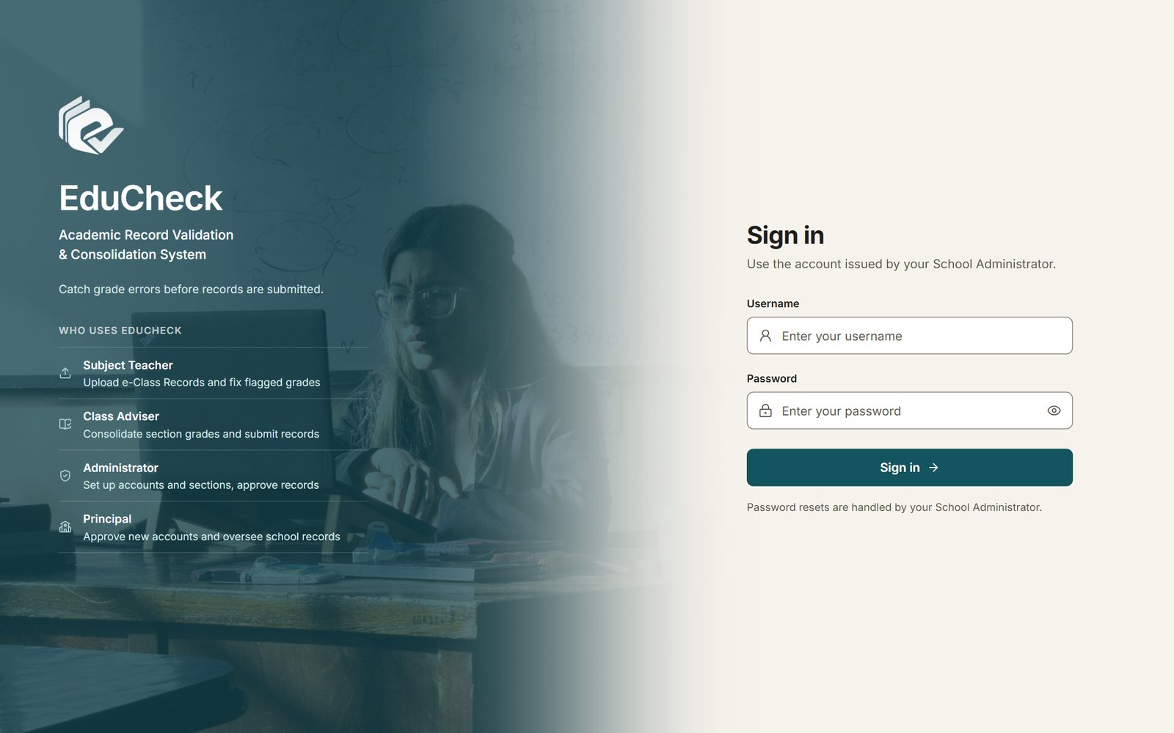
Figure 1. The sign-in page
- Type your Username and Password. Click the eye icon to check what you typed.
- Click Sign in.
- If this is your first sign-in, or your password was reset, EduCheck asks you to replace the temporary password before anything else. Choose a password of at least 8 characters with a letter and a number.

Note
After 10 wrong attempts in 15 minutes, sign-in is paused on that device for 15 minutes. A new account cannot sign in until the Principal approves it and the School Administrator finishes its setup.

Tip
On a hosted server, the first sign-in after a quiet period can take up to a minute while the server starts. EduCheck shows a message when this happens; keep the page open.

2.2 The welcome guide
The first time you sign in on a browser, a short guide opens. It explains what your role does, lists the pages you will use in order, and shows where each one is in the sidebar. Click Show me to go through the steps, or Skip to close it. The last page has a button that takes you to your first task.
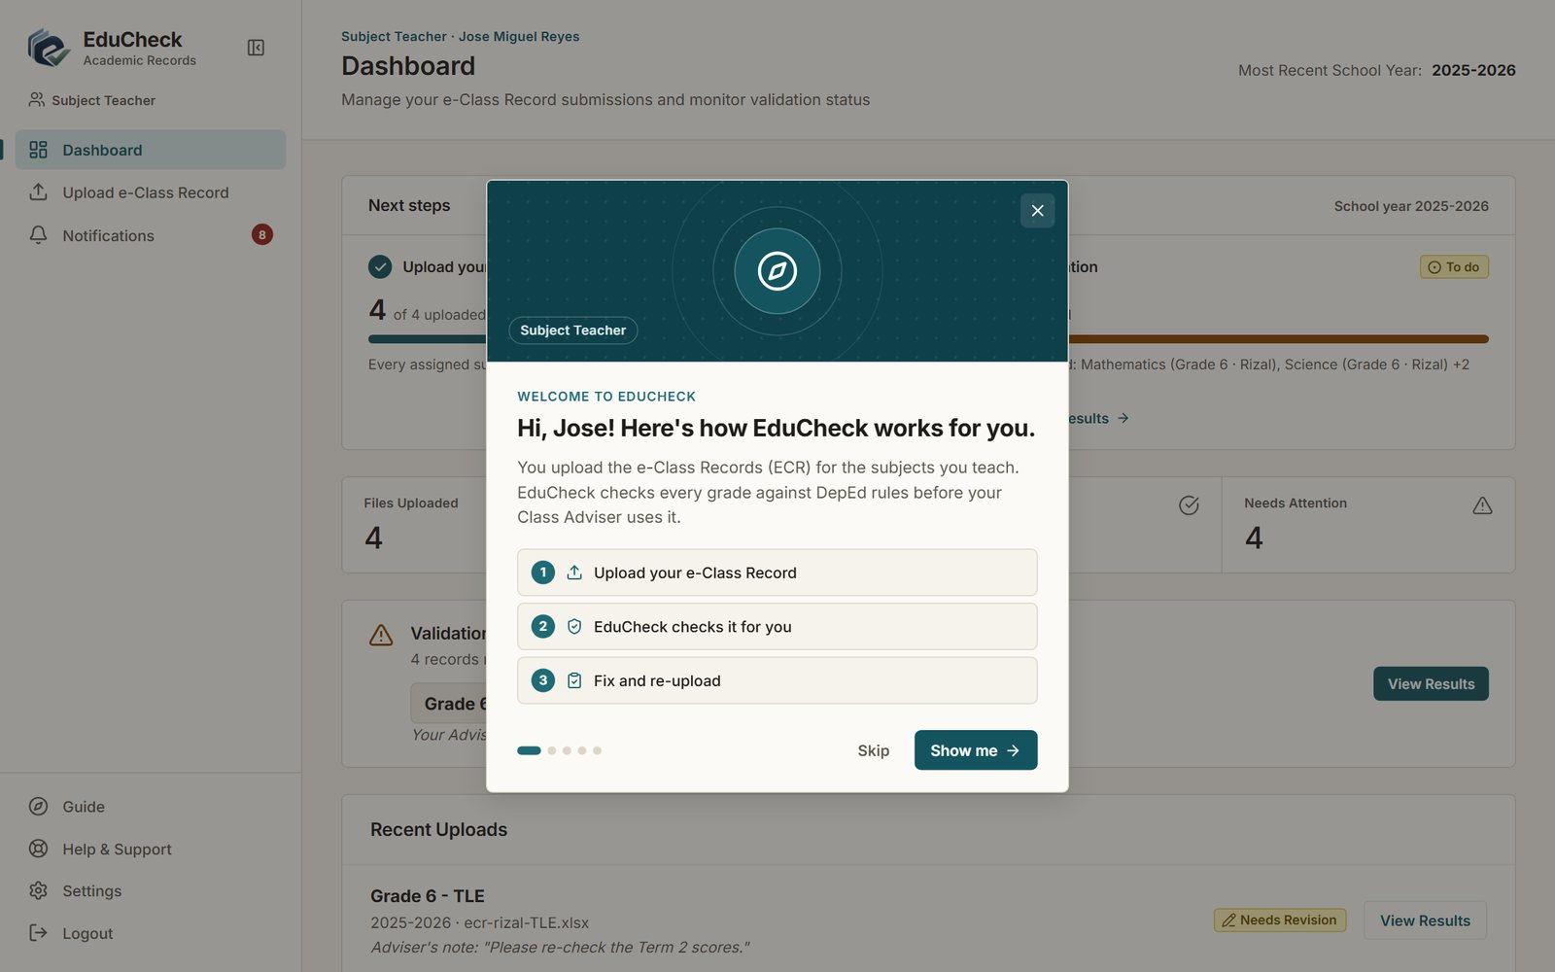
Figure 2. The welcome guide, first page (Subject Teacher)
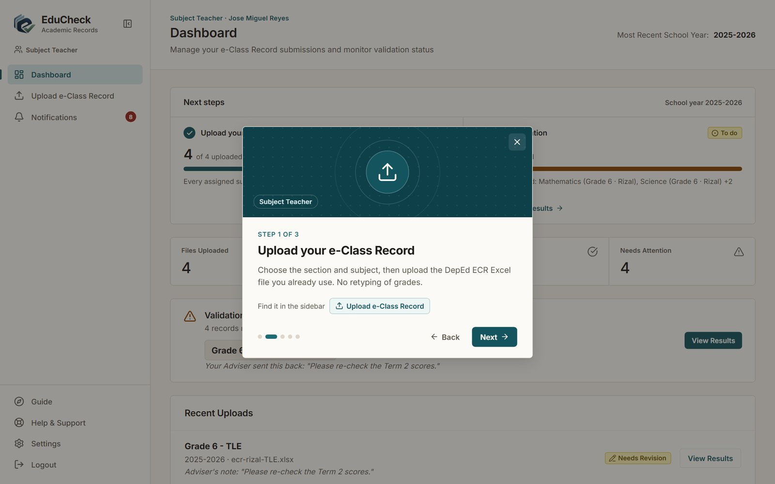
Figure 3. A step of the welcome guide, with the sidebar item to use
You can open the guide again at any time from Guide at the bottom of the sidebar.

2.3 Finding your way around
Every page has the same layout. The sidebar on the left lists the pages your role can open; the item you are on is highlighted. Its lower part holds Guide, Help & Support, Settings and Logout. The button beside the EduCheck logo collapses the sidebar to icons to give the page more room.
Many pages have a School Year selector at the top right. Pages open on the current school year; choose another year to see its records.

2.4 Notifications
EduCheck tells you when something needs your attention, for example when a record is returned, approved or submitted. The number beside Notifications in the sidebar shows how many are unread.
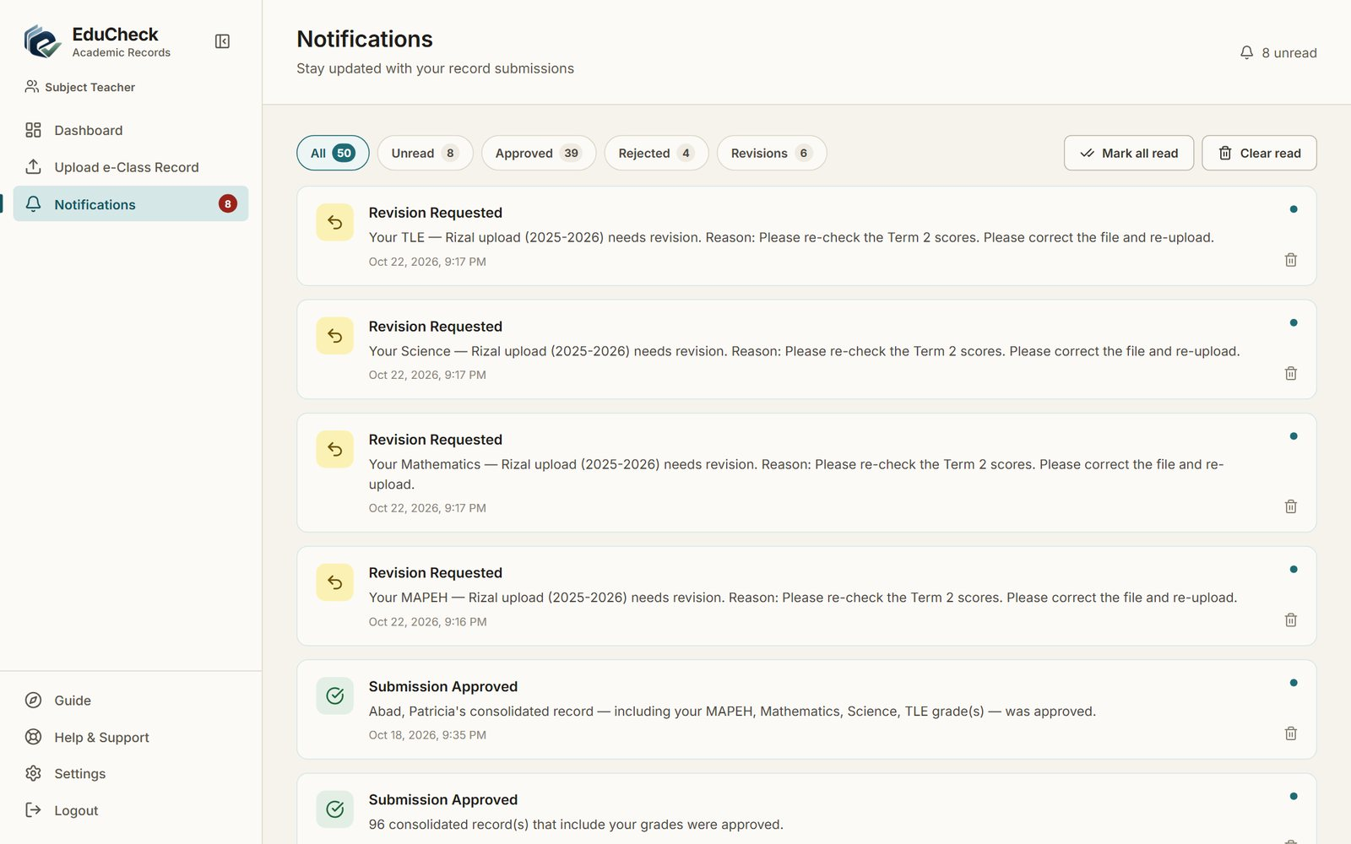
Figure 4. Notifications, filtered with the tabs at the top
- Use the tabs (All, Unread, Approved, Rejected, Revisions) to filter the list.
- Mark all read clears the unread count. Clear read removes notifications you have already read.
- The trash icon on a notification deletes it.

2.5 Settings
Settings shows your account details (read-only), the subjects and sections you are assigned to, the Appearance choice (Light or Dark), and Change Password.
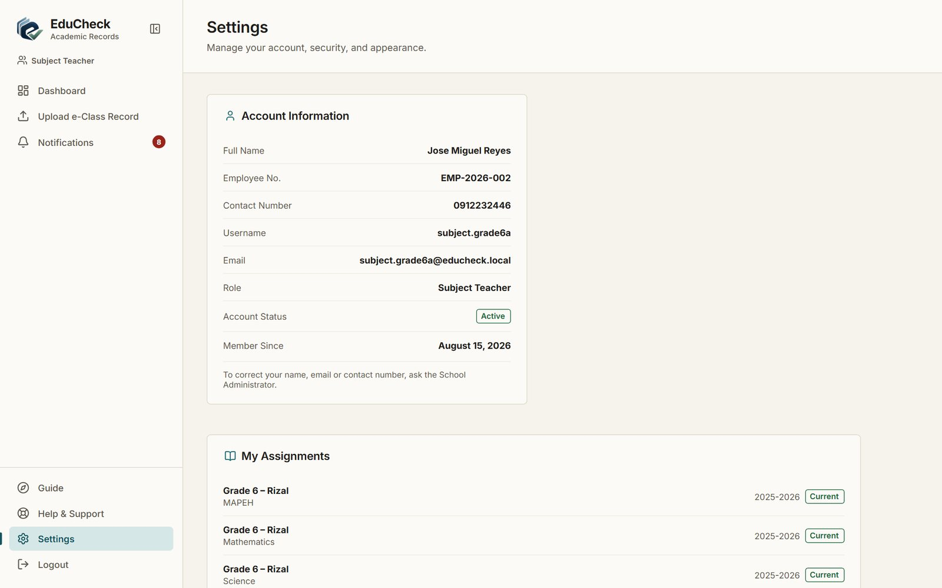
Figure 5. Settings for a Subject Teacher
To change your password, enter your current password, then the new one twice, and click Update Password. Your name, email and contact number are managed by the School Administrator; ask them to correct anything that is wrong.

2.6 Help & Support
Help & Support answers the questions your role asks most. Type a word such as password, upload or SF10 in the search box to find an answer quickly, and click a question to open it. The panel on the right tells you who to contact when you still need help.
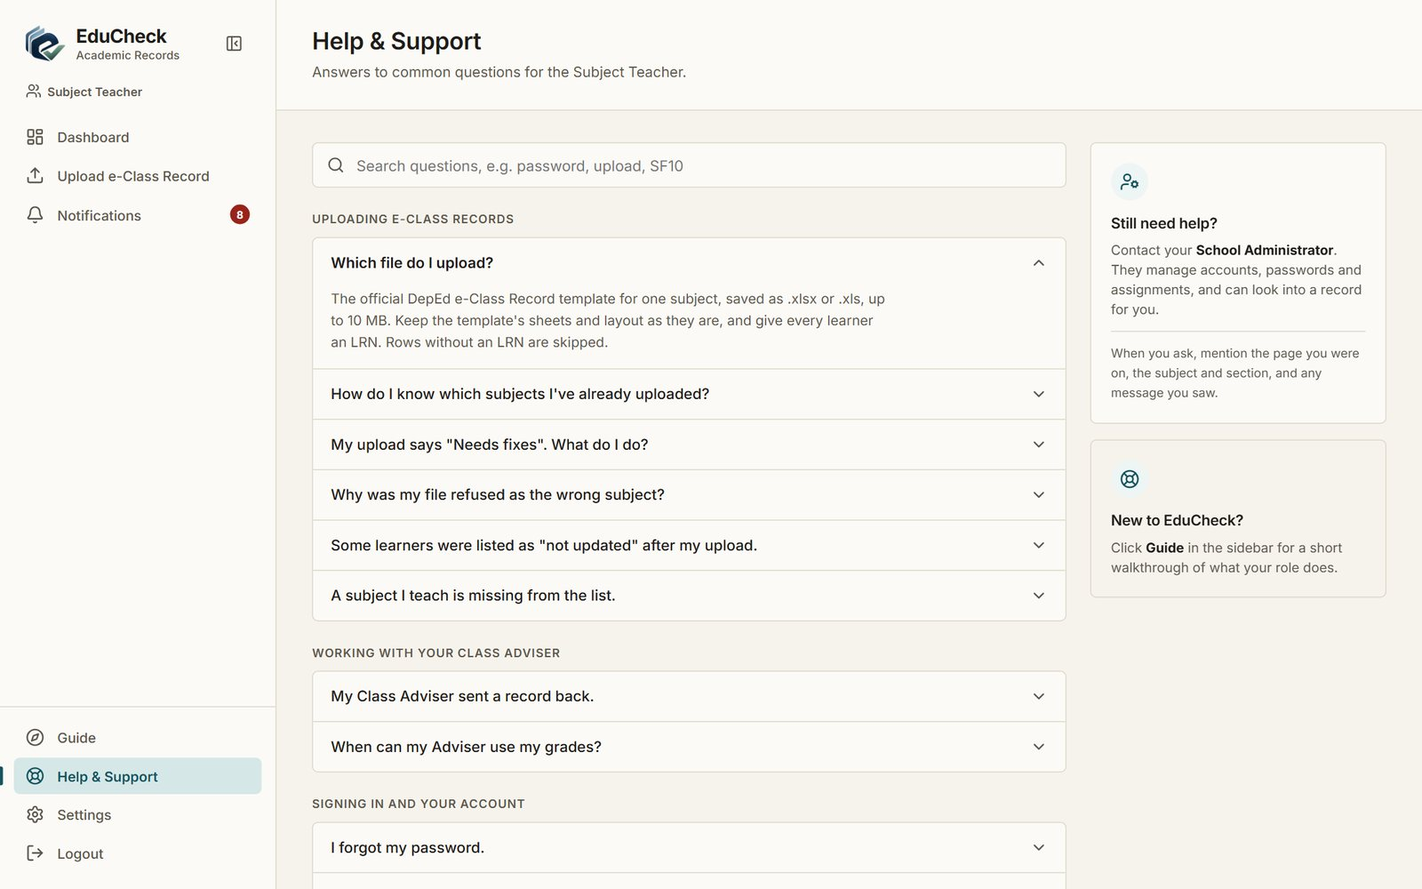
Figure 6. Help & Support, with an answer opened

2.7 Signing out
Click Logout at the bottom of the sidebar. Always sign out on a shared computer.

3. Subject Teacher
As a Subject Teacher you upload the e-Class Record of every subject and section you are assigned to, then fix anything EduCheck flags until each upload is validated.

3.1 Your dashboard
The dashboard shows Next steps: how many of your subjects are uploaded and how many passed validation, with a link to what is left. Below it are counts of your uploads, any records that need attention (including notes from your Class Adviser), and your recent uploads.
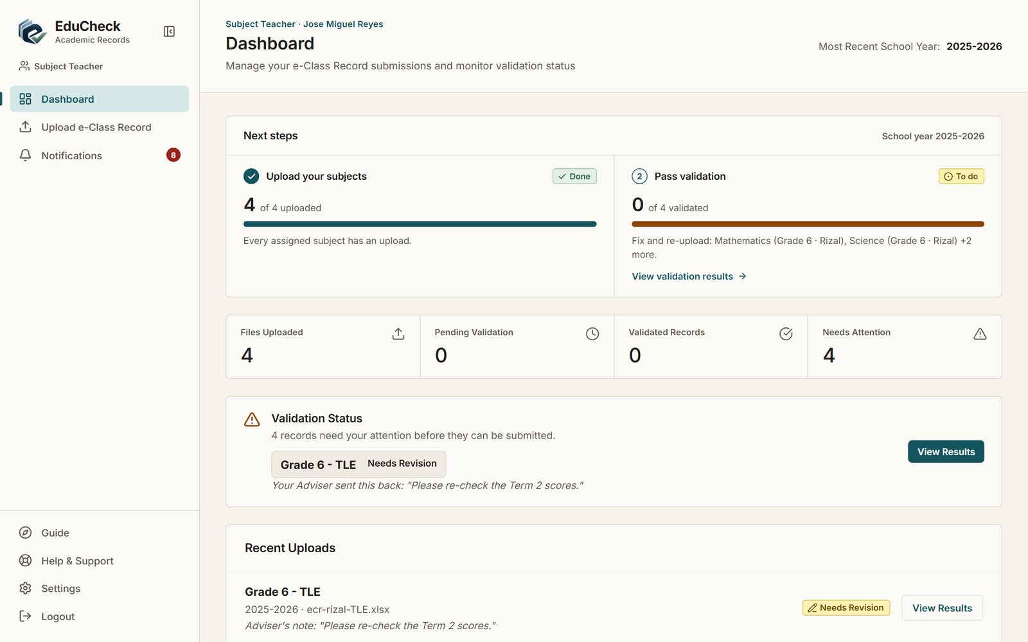
Figure 7. Subject Teacher dashboard

3.2 Uploading an e-Class Record
Open Upload e-Class Record in the sidebar.
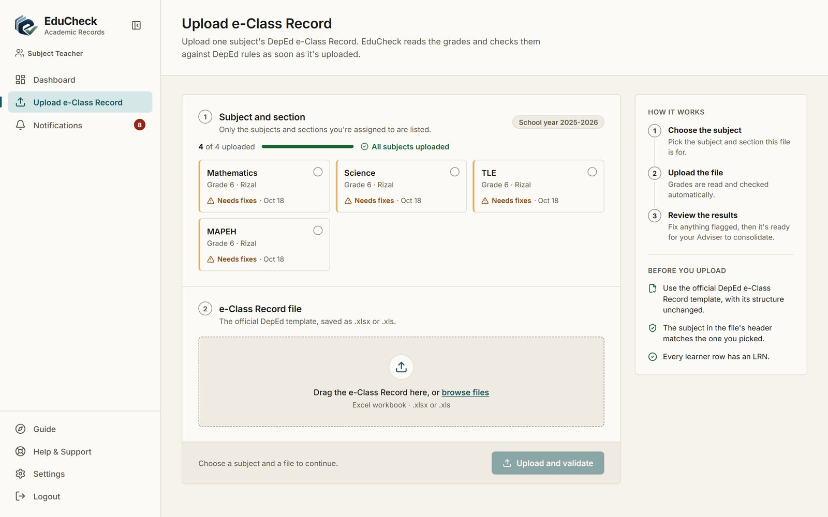
Figure 8. The upload page: each subject shows its status
- Under Subject and section, check each tile's status: Validated (green), Needs fixes (amber) or Not uploaded yet, with the date of the last upload. The count above the tiles shows how many subjects are uploaded, and the next subject not yet uploaded is already selected.
- Click the tile of the subject you are uploading.
- Drag the Excel file into the box, or click browse files and choose it.
- Click Upload and validate.
- Read the result. Uploaded and validated means the grades are ready for your Class Adviser. Uploaded — corrections needed means there are problems to fix; click View validation results.
- Click Upload another file for the next subject.

Note
Only the subjects and sections you are assigned to are listed. If one is missing, ask your School Administrator to add the assignment.

Before you upload, make sure that:
- the file is the official DepEd e-Class Record template with its structure unchanged;
- the subject written in the file's header (cell Y7 of the INPUT sheet) is the subject you selected — a file for a different subject is refused, while short names such as Math, AP, EsP, GMRC, TLE/EPP and MAPEH are accepted;
- every learner has an LRN, because rows without an LRN are skipped.

3.3 Reading the validation results
The validation results page lists every check EduCheck ran on the file: learners reviewed, missing data, invalid scores, duplicate entries and term or summary mismatches, followed by each issue found. A note from your Class Adviser appears at the top when they returned the record.
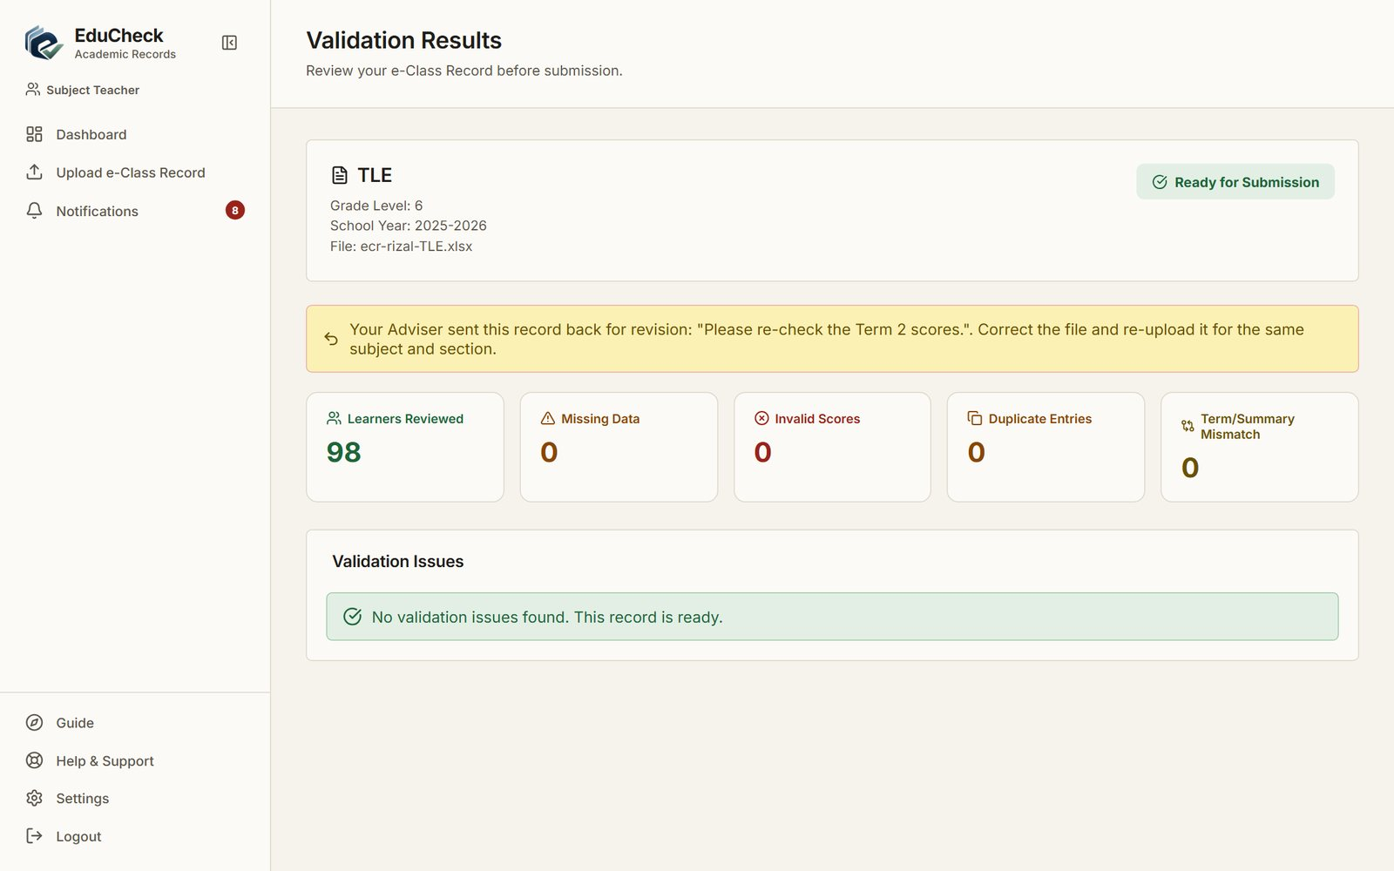
Figure 9. Validation results of an upload

3.4 Fixing and re-uploading
- Open the validation results and note each issue.
- Correct the cells in your Excel file. Grades are always corrected in the Excel file, not inside EduCheck.
- Upload the corrected file again for the same subject and section.

Note
Learners whose records are already Pending Approval or Approved are locked. The rest of the class is saved, and the locked learners are listed as not updated. To change a locked learner, the Class Adviser must first request a revision.

3.5 When your Class Adviser returns a record
If the Class Adviser finds a problem, they send the subject back with a reason. You receive a notification, and the reason appears on your dashboard and on the validation results page. Fix the file and upload it again; the subject's status returns to Validated once it passes.

4. Class Adviser
As a Class Adviser you follow your section's uploads, review each learner's consolidated record, submit complete records for approval, and keep each learner's permanent record (SF10). You see only the learners of the section you advise.

4.1 Your dashboard
Next steps shows the three stages of your work: subjects uploaded and validated, learner records complete, and records approved, each with what is still missing and a link to it. Below are your section's counts and a performance summary that highlights learners who may need intervention.
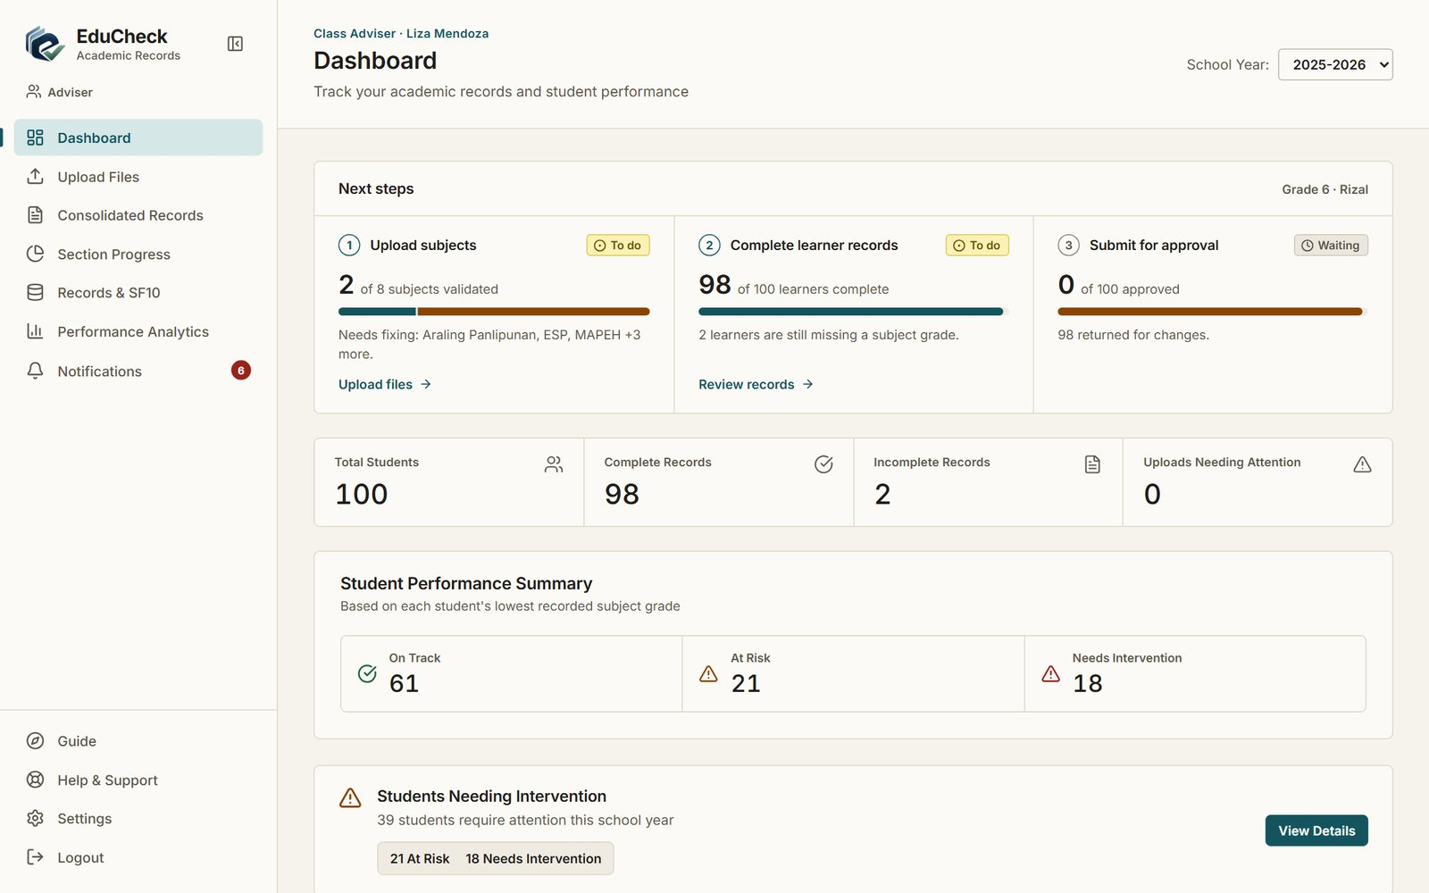
Figure 10. Class Adviser dashboard

4.2 Following your section's progress
Section Progress shows, for your section, how many learning areas are submitted, which need revision, and where learners stand in the approval workflow. Click View Students to open the section's learners.
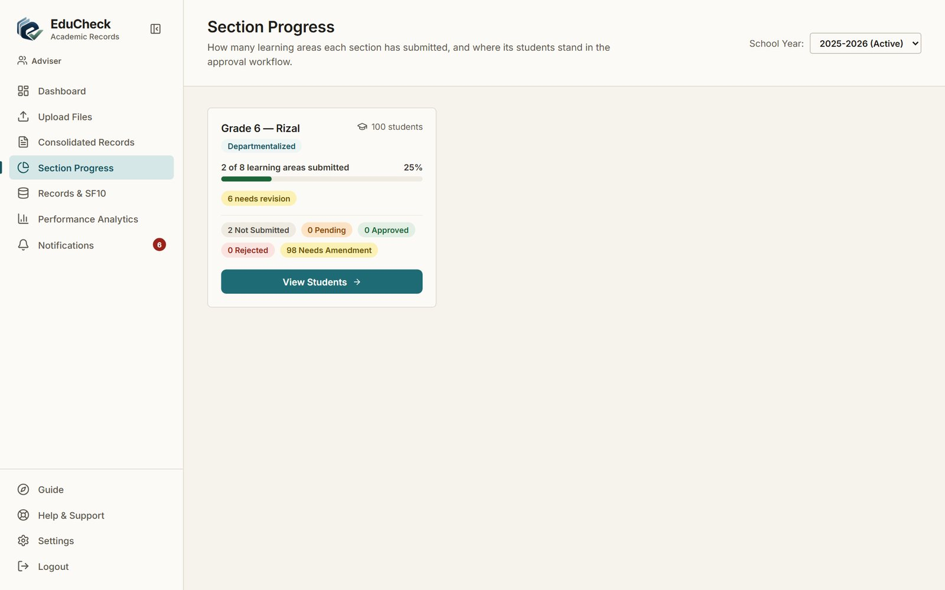
Figure 11. Section Progress

4.3 Reviewing consolidated records
Consolidated Records lists each learner with how many subjects have grades (for example 8 / 8) and the record's status. Use the search box to find a learner by name or LRN, and the tabs (All, Ready, Incomplete, Pending approval, Returned, Approved) to narrow the list.
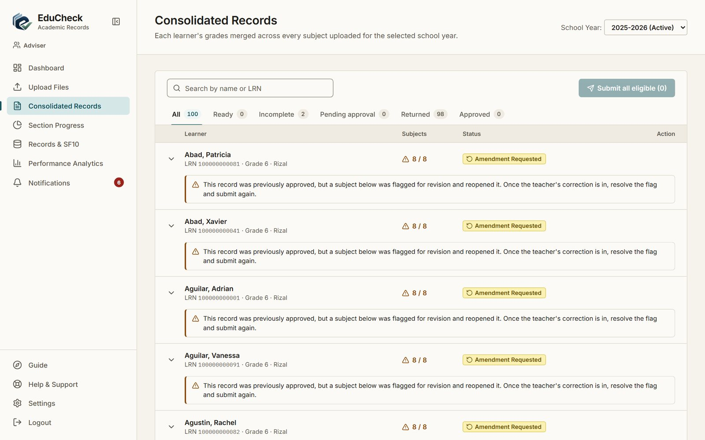
Figure 12. Consolidated Records for the Adviser's section
Click a learner to open their grades: one row per subject with the teacher, the term grades, the final grade and the subject's status.
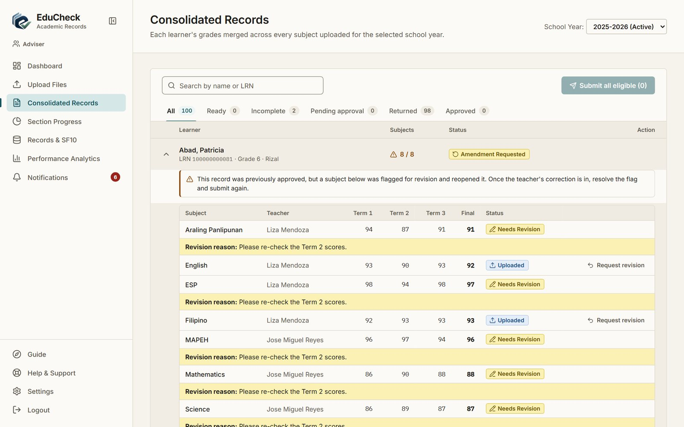
Figure 13. A learner's consolidated grades, with revision reasons

Sending a subject back to its teacher
- Open the learner and find the subject.
- Click Request revision on that subject.
- Type the reason, for example which scores to re-check. A reason is required.
- Click Confirm Request. The subject teacher is notified, and the subject shows Needs Revision until a corrected file is uploaded.

4.4 Submitting records for approval
A learner's record can be submitted when every subject is Validated, every term has a final grade, and no subject is waiting for a revision. EduCheck shows what is still missing for a record that cannot be submitted yet.
- Click Submit on a learner whose record is ready, or click Submit all eligible to submit every ready record at once.
- The record becomes Pending approval and the School Administrator is notified.
- If the Administrator returns a record, it shows Returned with the reason. Fix the problem, then submit it again.

Note
A submitted or approved record is locked. To change it, request a revision on the subject that needs correcting; the record reopens as Amendment Requested, and you submit it again after the correction.

4.5 Uploading your own subjects
If your section is Self-Contained, or you are assigned subjects of your own, Upload Files appears in your sidebar. It works exactly like the Subject Teacher upload in section 3.2.
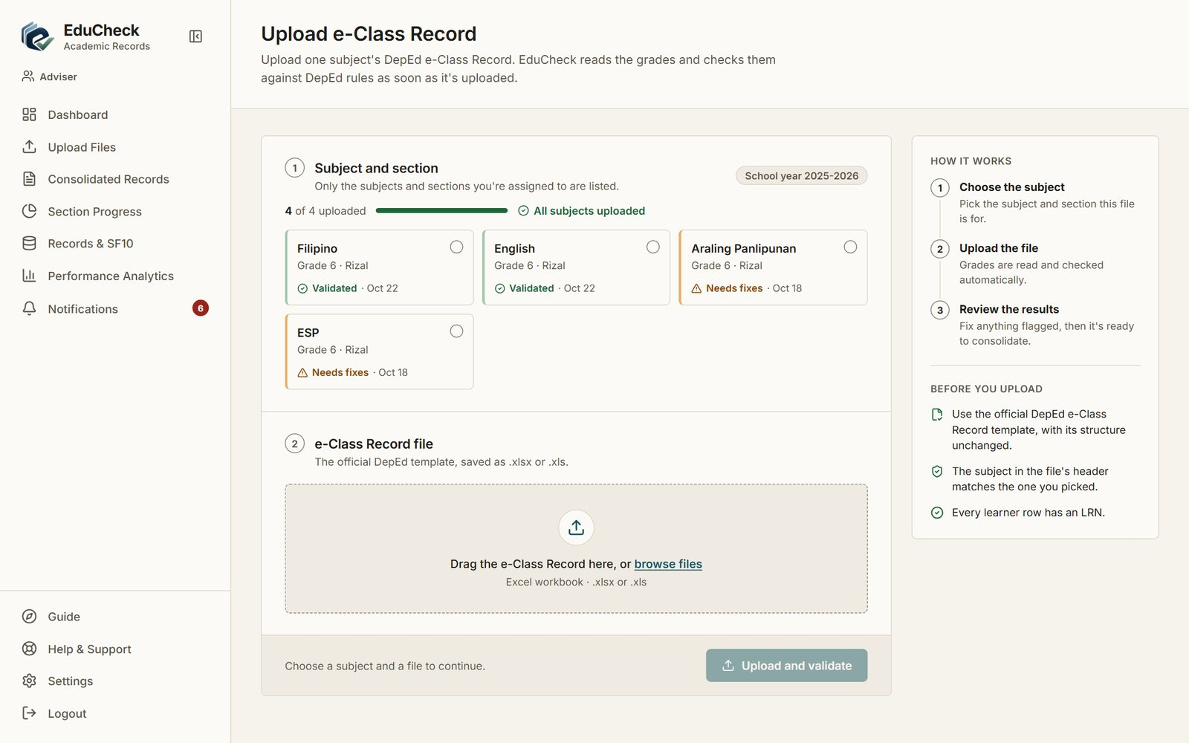
Figure 14. Upload Files for an Adviser who teaches four subjects

4.6 Records and SF10
Records & SF10 finds learners by LRN or name, grade level or school year. For each learner, Permanent Record (SF10) opens the SF10 page, and the school-year button opens that year's consolidated grades.
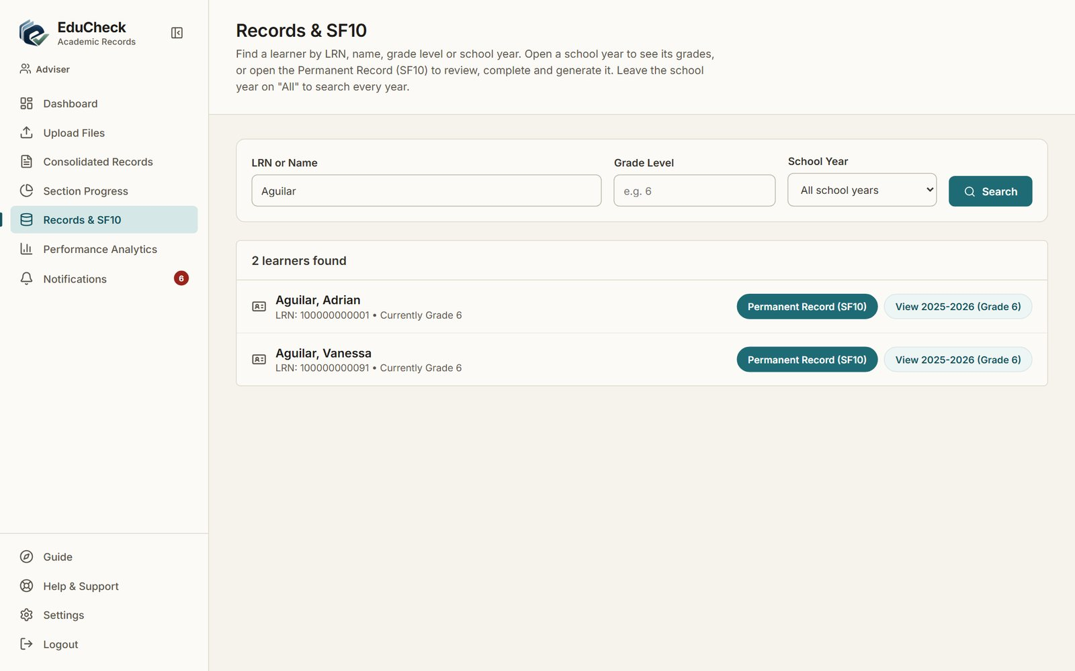
Figure 15. Searching Records & SF10
The SF10 page shows how ready the form is (Readiness), the scholastic record for Grades 1 to 6, the learner's details and the school details.
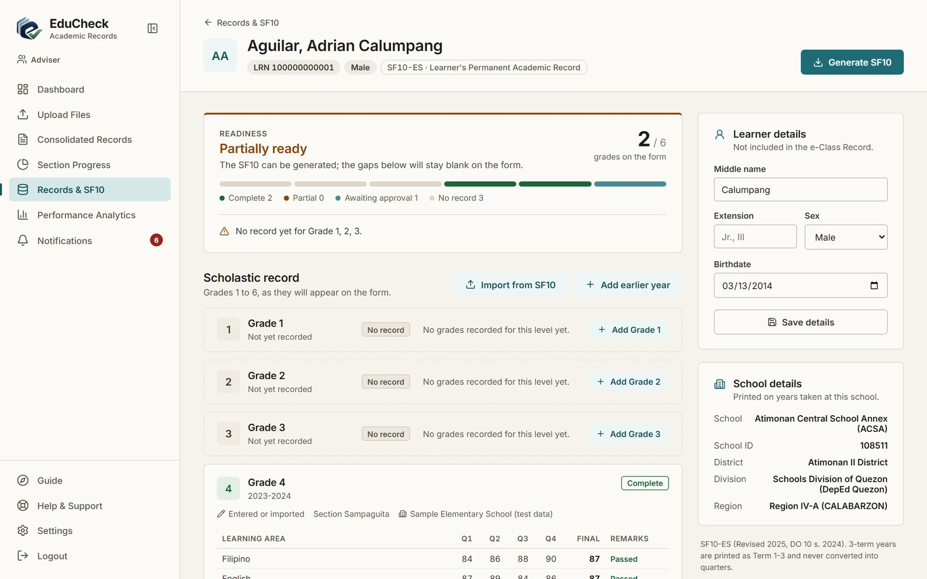
Figure 16. A learner's permanent record (SF10)
- Generate SF10 downloads the official SF10-ES form with every year that has grades.
- Add earlier year (or Add Grade on a level) types in a year taken before EduCheck, such as at another school.
- Import from SF10 reads earlier years from the learner's existing SF10-ES Excel file. It shows a preview and saves only the years you tick. A file with another learner's LRN is refused.
- Learner details (middle name, extension, sex, birthdate) are not in the e-Class Record; complete them here and click Save details.
Note
A school year appears on the SF10 once its record is Approved. A year graded in three terms is printed in three of the form's four rating columns, labelled T1 to T3; EduCheck never converts terms into quarters.

4.7 Performance analytics
Performance Analytics shows your section's graded entries, average final grade, pass rate and at-risk entries, with an Intervention Flag List of learners whose grades fall below the passing mark of 75.
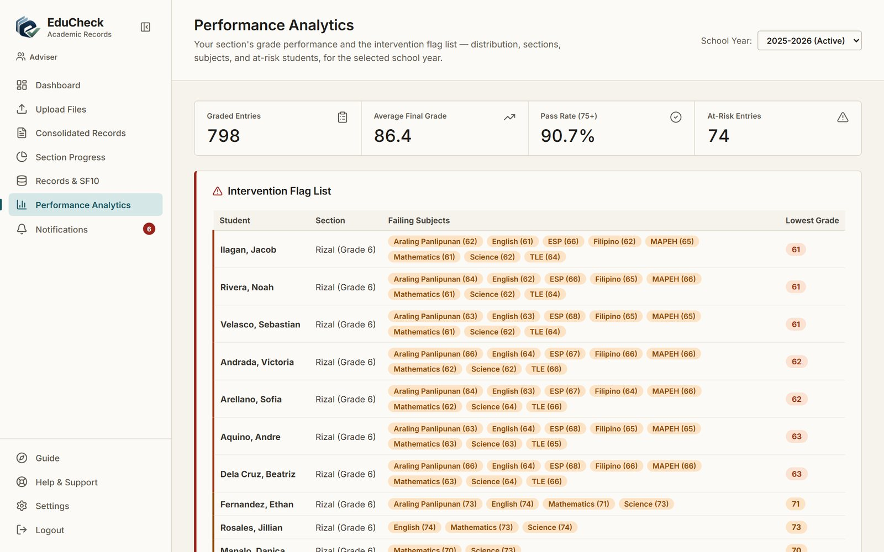
Figure 17. Performance Analytics with the intervention flag list

5. School Administrator
As the School Administrator you set EduCheck up for the school year, manage accounts, approve the records Class Advisers submit, and keep an eye on activity.

5.1 Your dashboard
The dashboard shows totals for users and submissions, the most recent submissions, and quick links to the pages you use most.
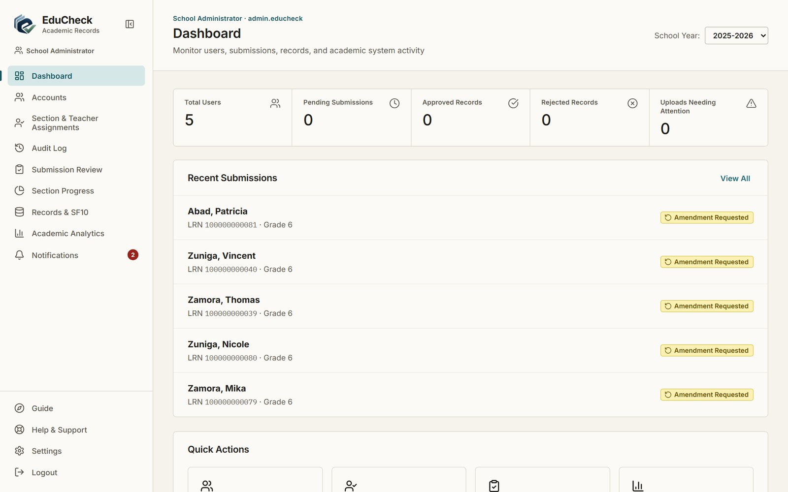
Figure 18. School Administrator dashboard

5.2 School years
Open Settings and find School Years. Open a new school year before assigning teachers to it; a learner keeps the same LRN every year, so they can be uploaded under a new grade and section in the new school year.
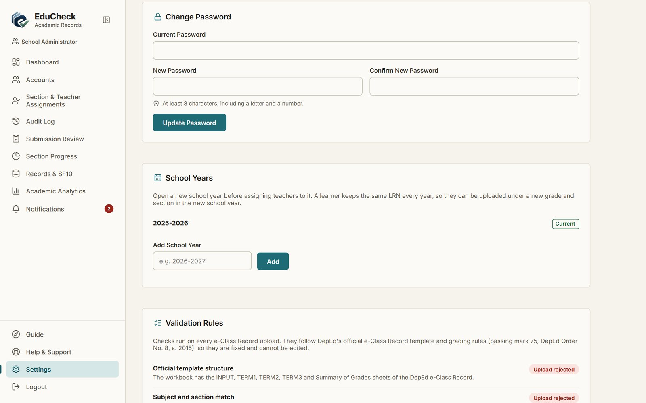
Figure 19. School Years and Validation Rules in Settings
- Type the school year as two consecutive years, for example 2026-2027, under Add School Year, and click Add. It is added as Inactive.
- When the new year starts, click Set as current beside it. Pages open on the current year; records of other years stay available.

Validation Rules in Settings lists every check run on an upload and what happens when it fails. The rules follow DepEd grading policy, so they cannot be edited.

5.3 Accounts
Accounts lists everyone who can sign in, with their role, employee number, email and status. Use the search box to find an account.
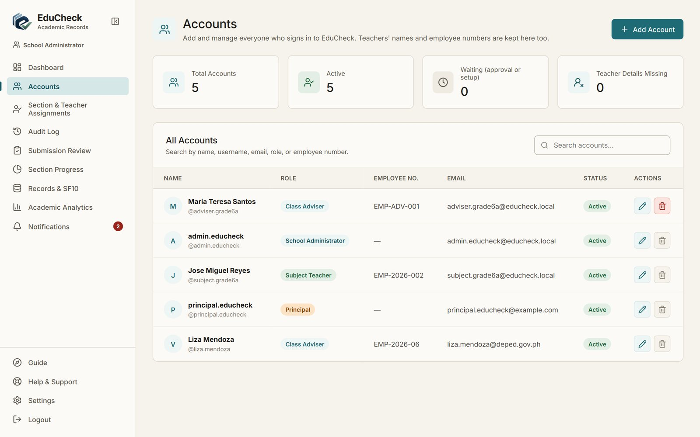
Figure 20. Accounts

Creating an account
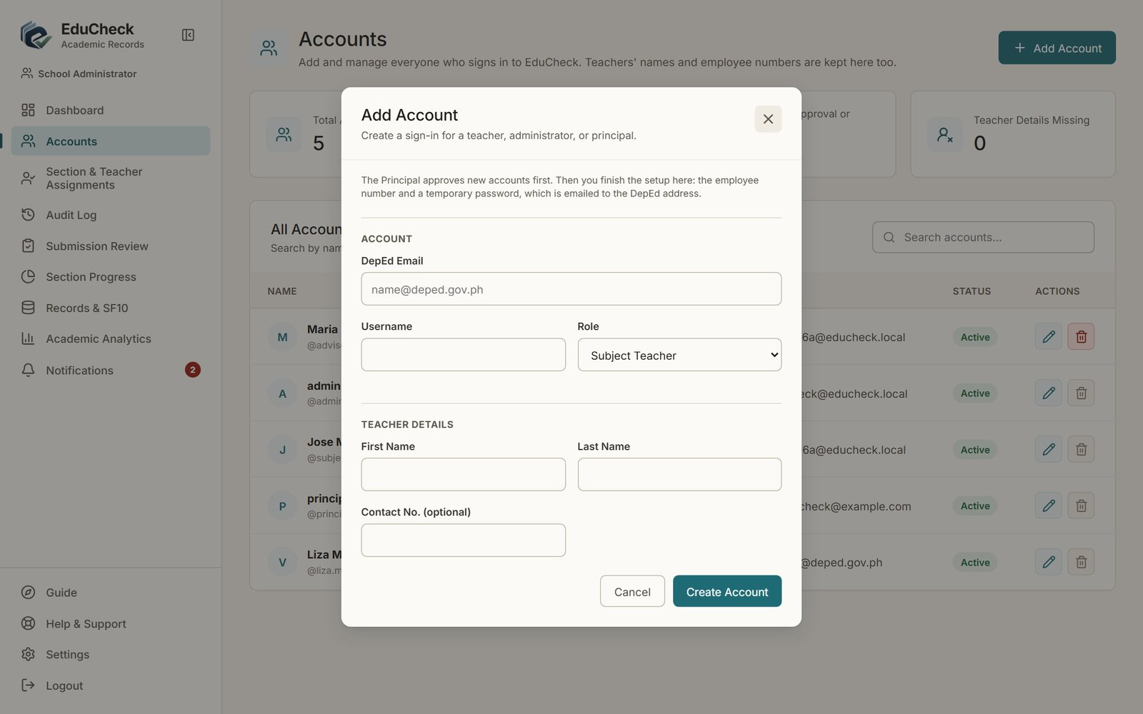
Figure 21. Add Account
- Click Add Account.
- Enter the person's DepEd Email (ending in @deped.gov.ph), a Username and the Role. For a Subject Teacher or Class Adviser, also enter the first and last name under Teacher Details.
- Click Create Account. The account waits for the Principal's approval.
- After the Principal approves it, click Finish setup on the account. Enter the employee number and a temporary password (or click Generate). The username and temporary password are emailed to the person's DepEd address; if the email cannot be sent, the password is shown so you can hand it over.
- The person signs in and replaces the temporary password.

Note
When there is no active Principal account (first setup), new accounts skip approval. A role change that gives more access also waits for the Principal; removing access applies at once.

Editing, resetting a password and deactivating
- Click the pencil icon to edit an account's details, role or status.
- To reset a forgotten password, edit the account and use Reset Password. The user must replace it at their next sign-in.
- To stop someone from signing in, set the status to Inactive.
- An account can be deleted only if it has no records in EduCheck. Otherwise the delete button is greyed out and explains why; set the account to Inactive instead.

5.4 Sections and teacher assignments
Section & Teacher Assignments sets up each section and who teaches it.
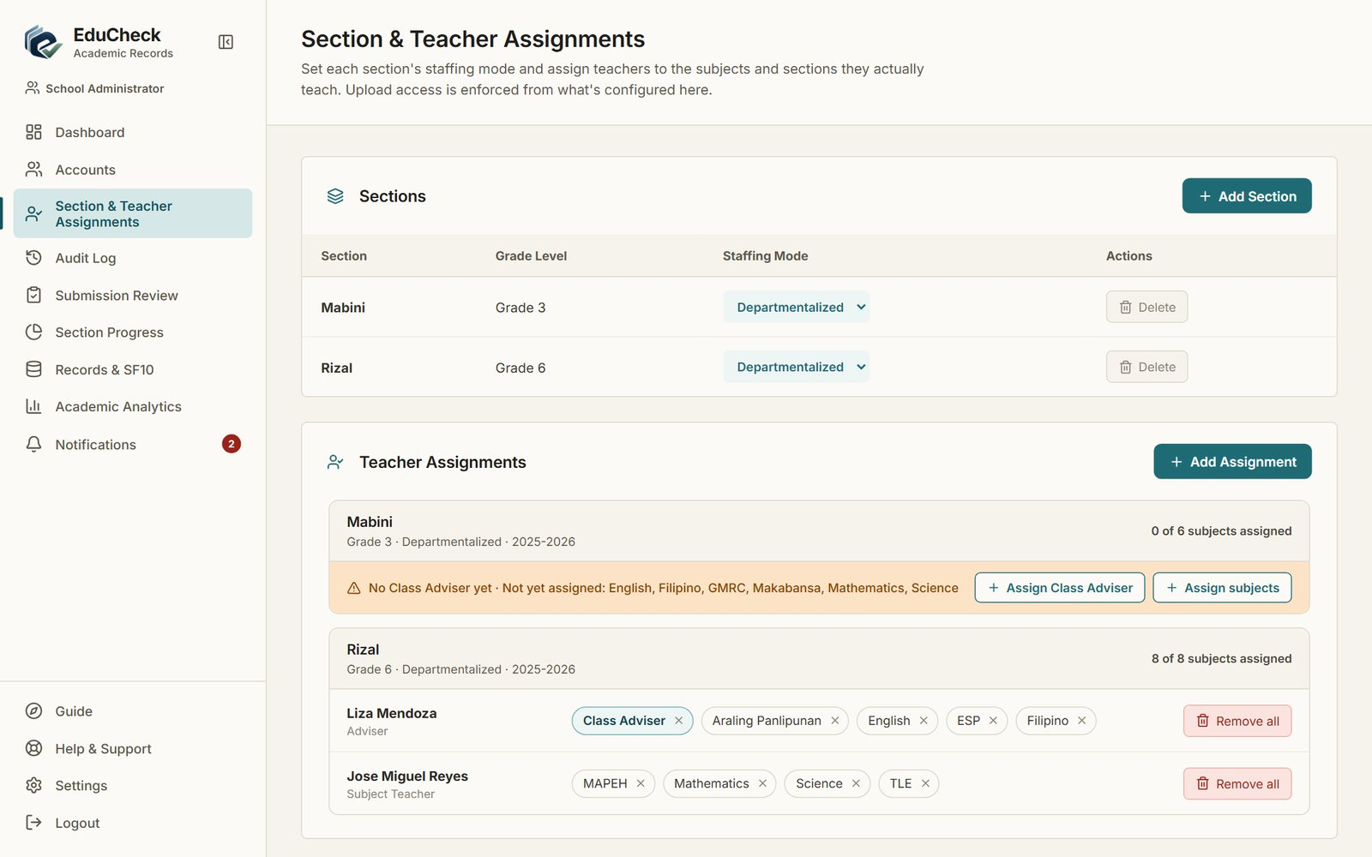
Figure 22. Sections and teacher assignments
- Click Add Section and enter the section name, grade level and Staffing Mode: Departmentalized (subjects are taught by different teachers) or Self-Contained (the Class Adviser teaches every subject). The staffing mode can be changed later from the section list.
- Under Teacher Assignments, use Assign Class Adviser and Assign subjects (or Add Assignment) to assign teachers for the school year. Each section shows how many of its subjects are assigned and which are still missing.
- Remove one assignment with the x on its chip, or all of a teacher's assignments in a section with Remove all.

Note
A section that already has class records or learners cannot be deleted; its delete button is greyed out and explains why.

5.5 Reviewing and approving submitted records
Submission Review lists every learner of the school year. Use the Section selector beside the School Year to show one section, the search box to find a learner, and the tabs to show, for example, only Pending approval records.
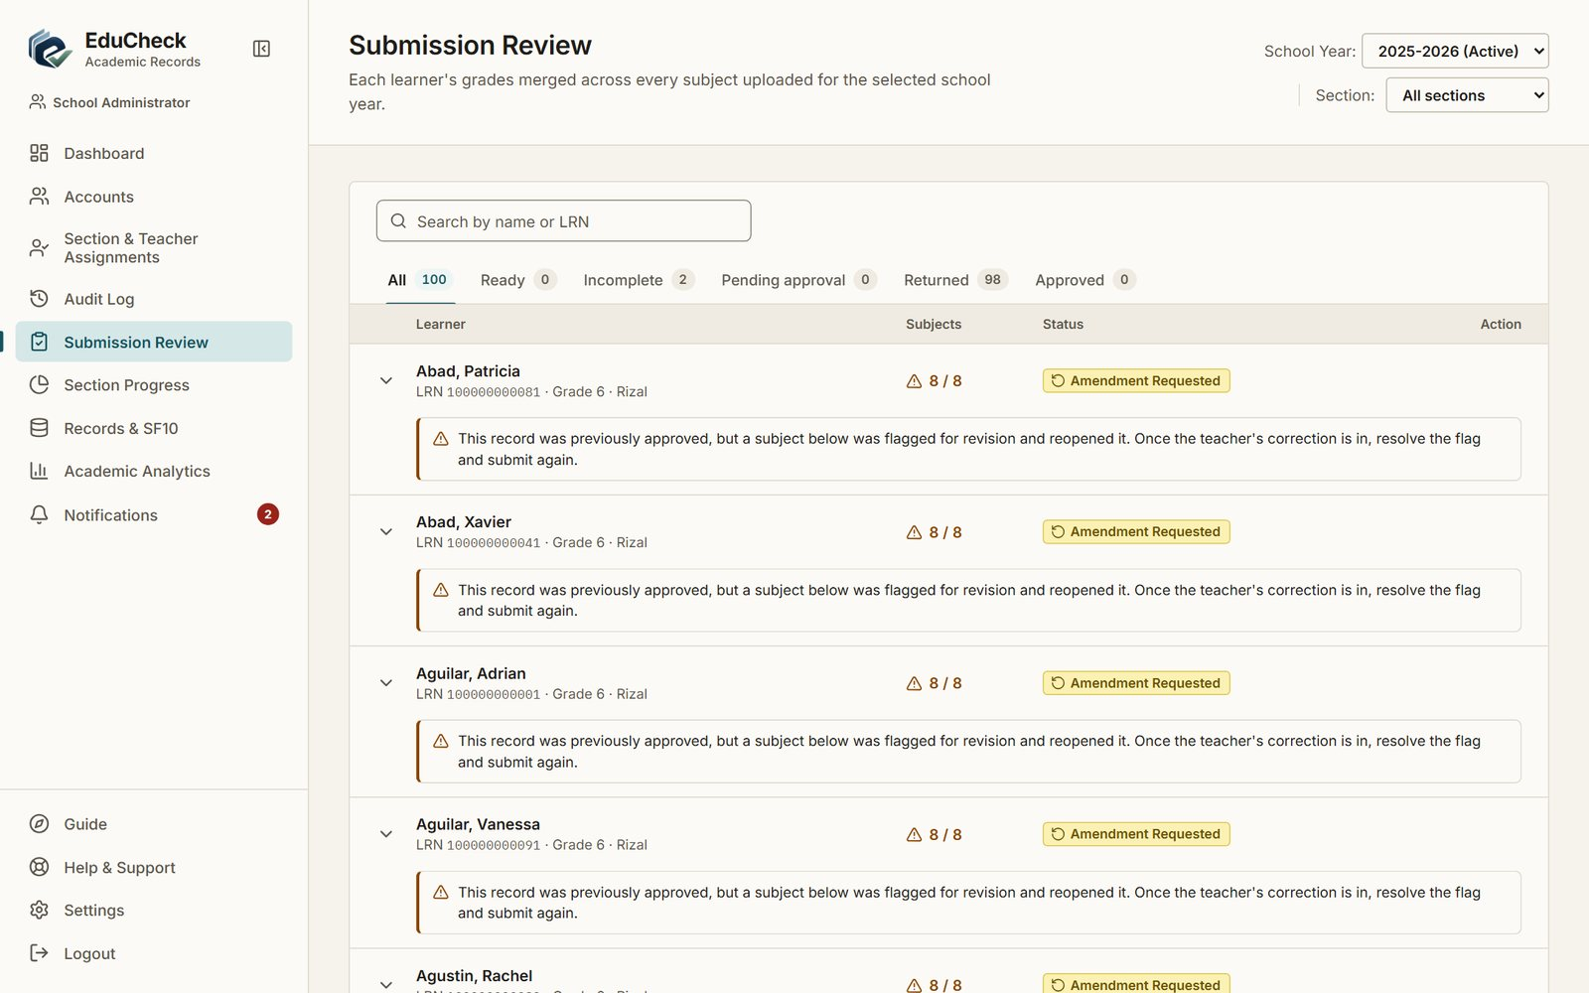
Figure 23. Submission Review
- Open a learner to check their grades.
- Click Approve to approve the record, or Reject to return it to the Class Adviser. A reason is required when rejecting; click Confirm Reject.
- To approve several records at once, tick them (or Select all pending) and click Approve selected.

Section Progress shows every section side by side, so you can see which sections are complete.
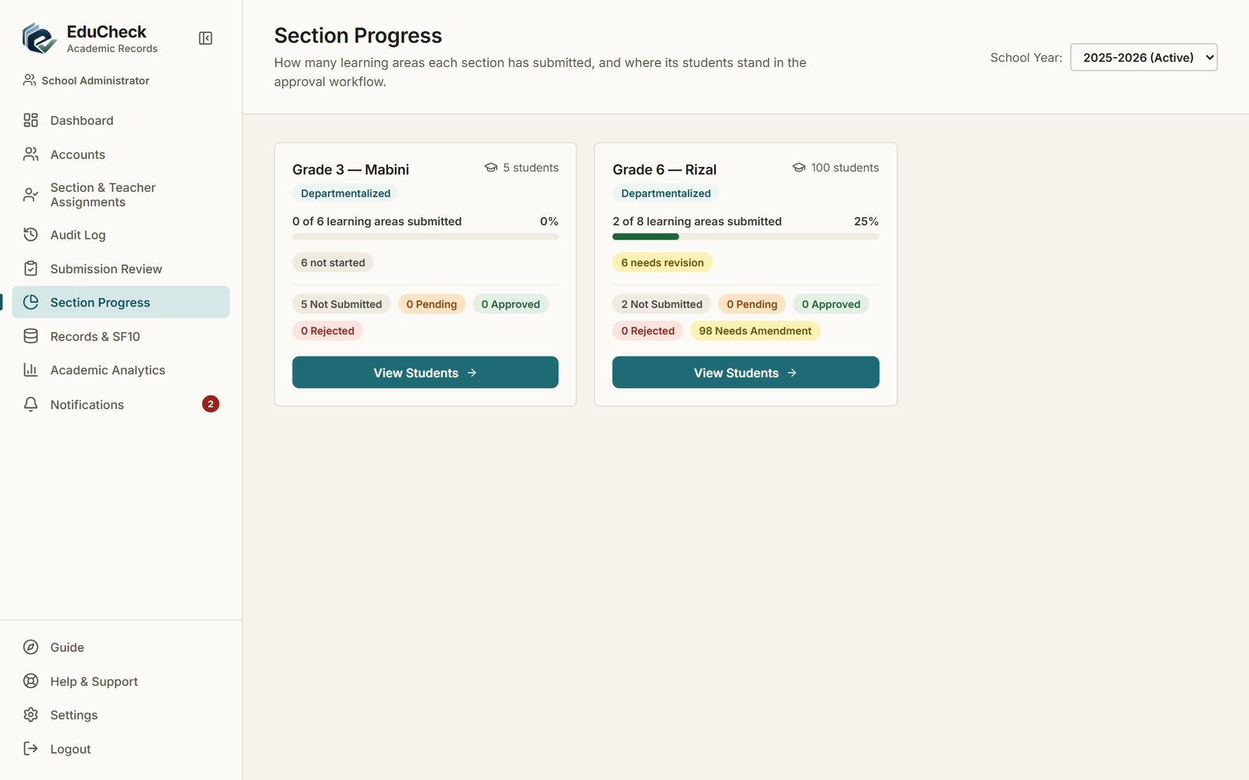
Figure 24. Section Progress for all sections

5.6 SF10 school details
On any learner's SF10 page (see section 4.6), the School details panel holds the school name, school ID, district, division and region printed on the form. Set them once and click Save school details.

5.7 Academic analytics
Academic Analytics shows school-wide grade performance, the sections and subjects, and the learners flagged for intervention for the selected school year.
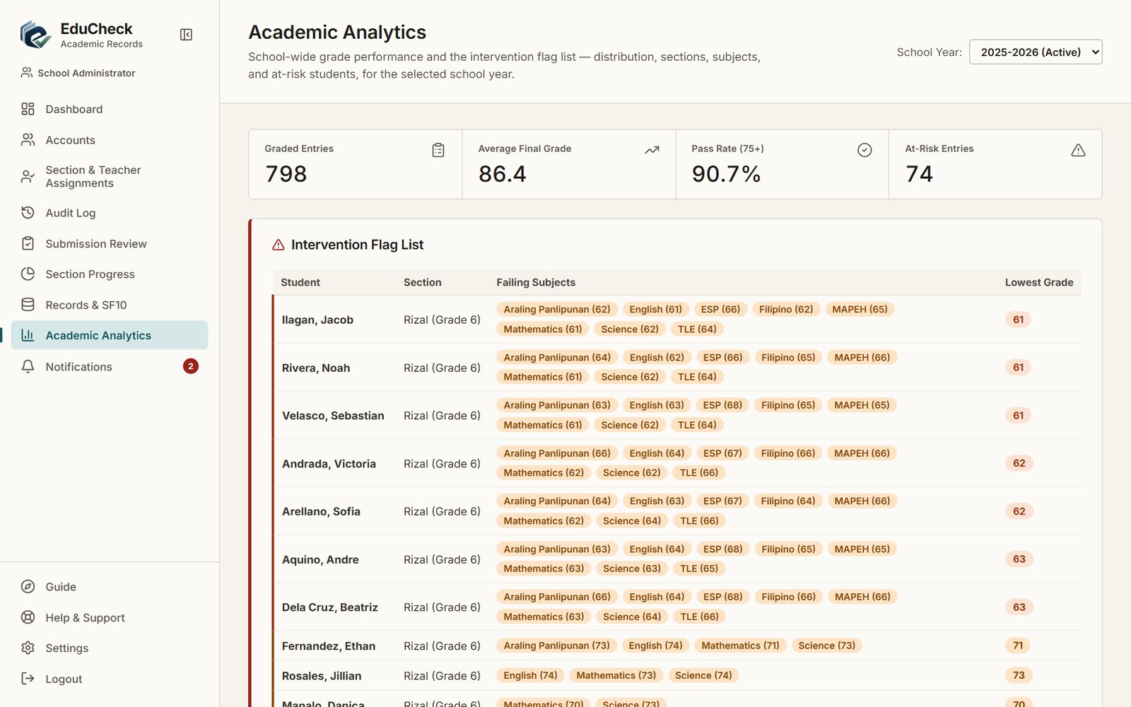
Figure 25. Academic Analytics

5.8 Audit log
Audit Log records every change to accounts, sections, teacher assignments and school years: who made it, when, and what changed. Entries are grouped by day; open one to see the details, and use Entity to filter by type.
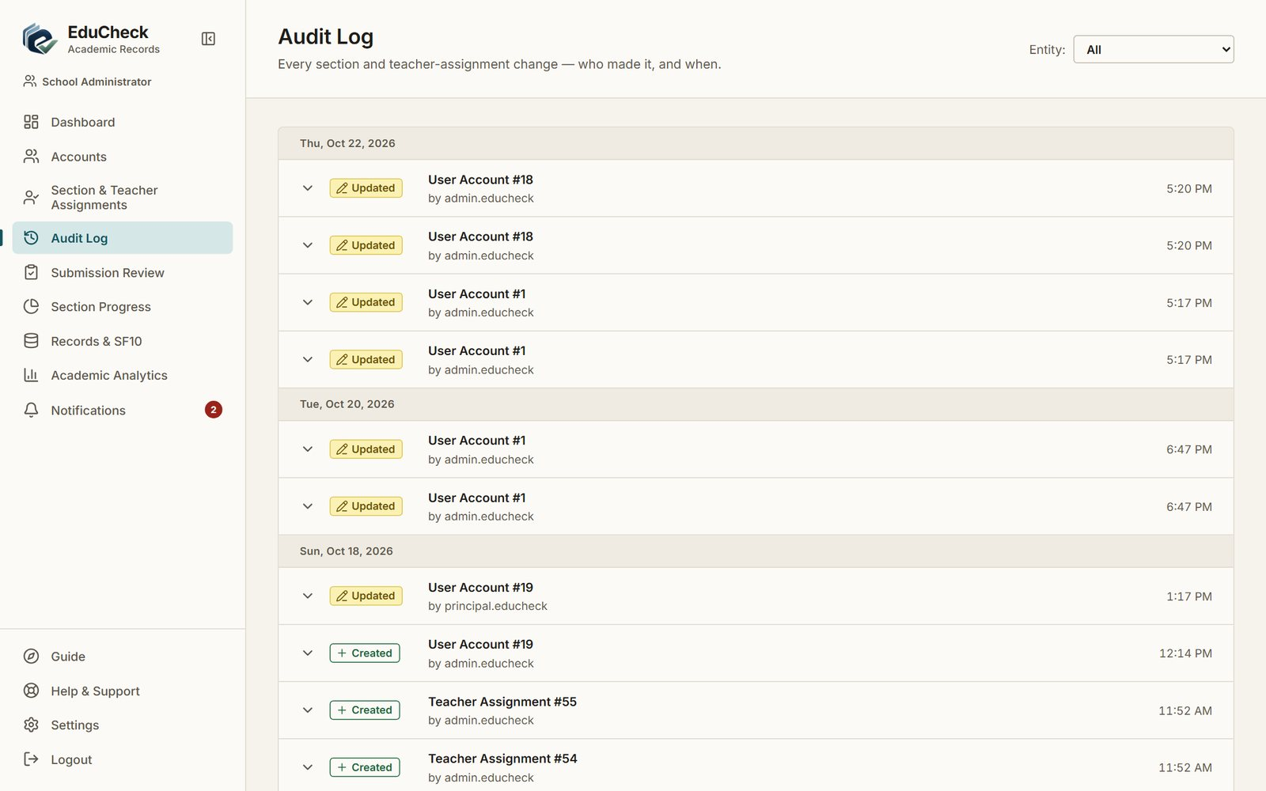
Figure 26. Audit Log

6. Principal
As the Principal you oversee the school's academic records. You can view every record, progress page and analytics page, and your one action is approving accounts. You cannot upload, edit or approve records.

6.1 Your dashboard
The dashboard shows how many sections are fully submitted and the counts of pending, approved and rejected records, with links to Section Progress, Submission Review and Records & SF10.
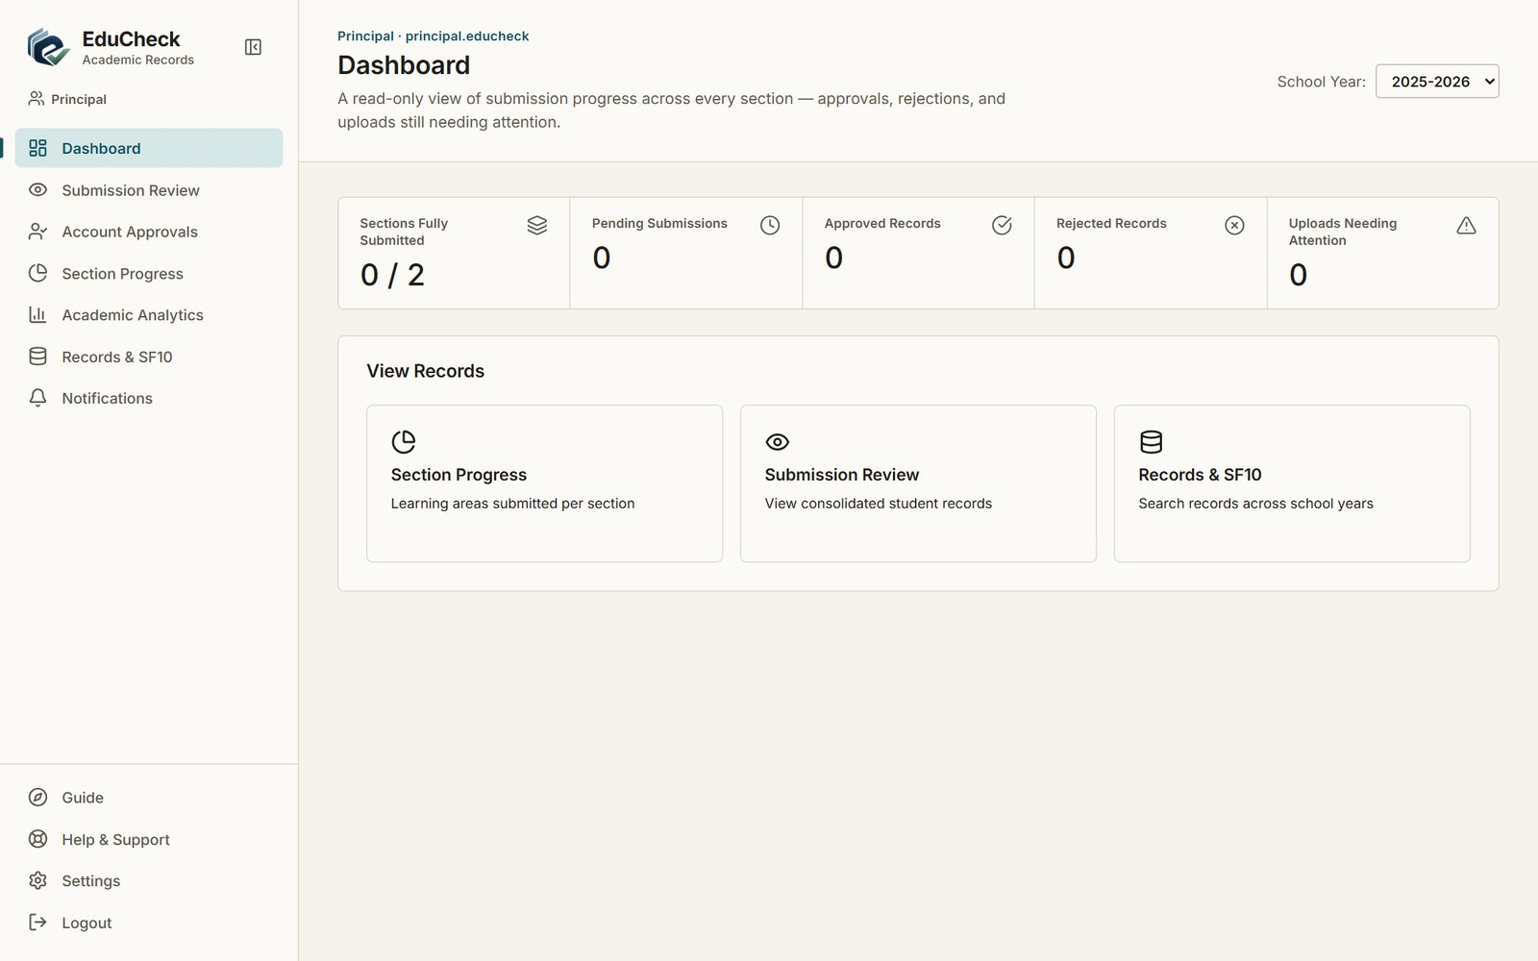
Figure 27. Principal dashboard

6.2 Approving accounts
Account Approvals lists the new accounts the School Administrator created and the role changes that give more access. Nothing listed here can be used until you approve it.
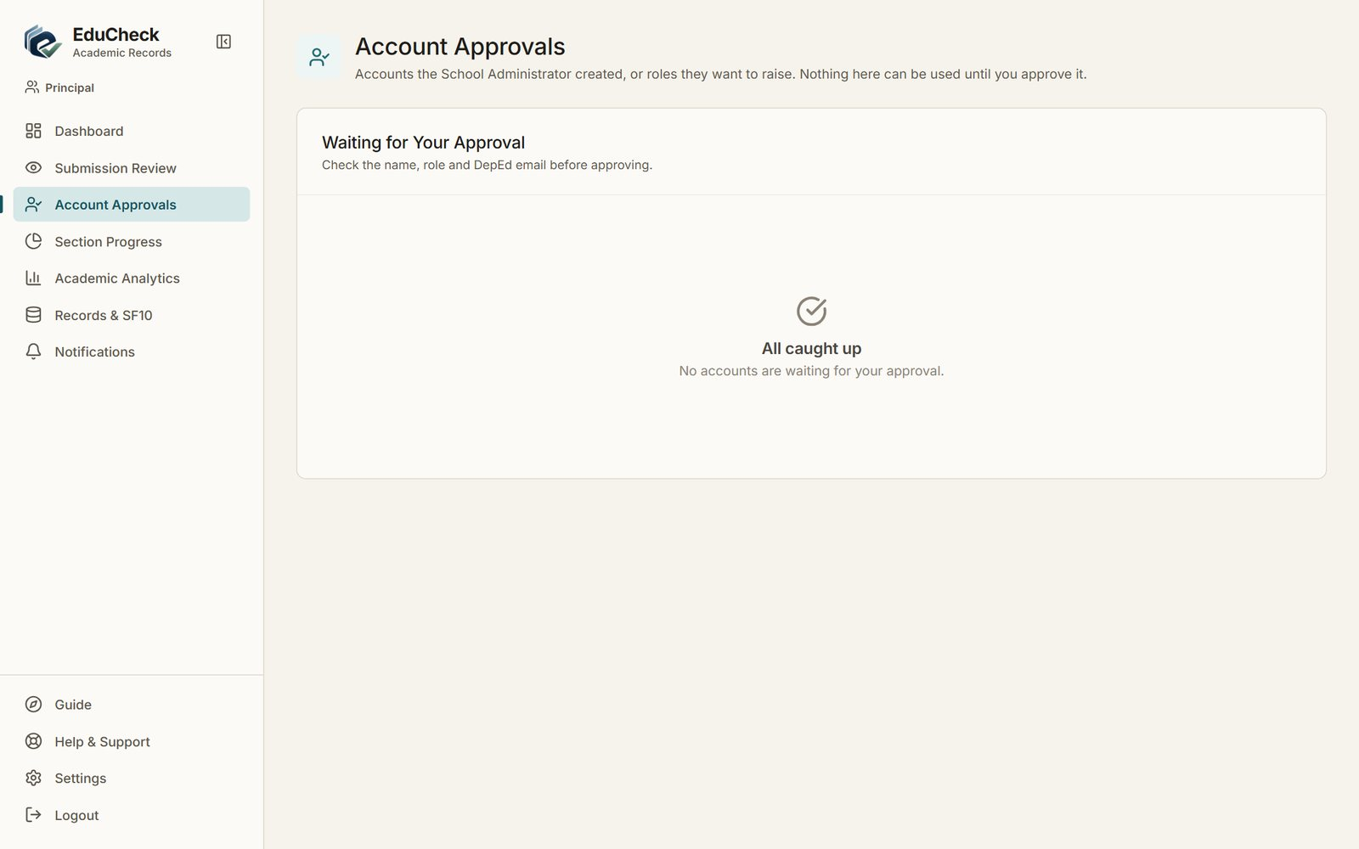
Figure 28. Account Approvals with nothing waiting
- Check the person's name, role and DepEd email.
- Click Approve. To reject, click Reject, type the reason and click Confirm Reject; the reason is shown to the School Administrator.
- An approved new account still needs the Administrator to finish its setup before the person can sign in.

6.3 Viewing records and analytics
- Submission Review shows each learner's consolidated record and its approval status (view-only).
- Section Progress shows where each section's uploads and submissions stand.
- Academic Analytics shows grade distributions, subject performance and learners who may need intervention.
- Records & SF10 finds any learner and opens their permanent record.

7. Troubleshooting
Problem | What to do
I forgot my password. | Ask the School Administrator to reset it. A temporary password is sent to your DepEd email (check the spam folder), and you replace it when you sign in.
"Too many login attempts" | Sign-in is paused after 10 wrong attempts in 15 minutes. Wait 15 minutes, then try again with the correct password.
Sign-in takes a long time. | On a hosted server, the first sign-in after a quiet period can take up to a minute while the server starts. Keep the page open.
A subject or section is missing on the upload page. | You are not assigned to it. Ask the School Administrator to add the assignment.
My file was refused as the wrong subject. | The subject in the file's header (INPUT sheet, cell Y7) must match the subject you selected.
Some learners were "not updated". | Their records are Pending Approval or Approved, so they are locked. The Class Adviser must request a revision first.
A learner cannot be submitted. | Every subject must be Validated with a final grade for every term, and no subject may be waiting for a revision. EduCheck lists what is missing.
The SF10 says there is nothing to put on it yet. | A year is printed only after it is Approved. Earlier years can be added or imported on the SF10 page.
A section or account cannot be deleted. | It already has records, which EduCheck keeps. Set an account to Inactive instead.
Notifications don't reach my phone. | The mobile app checks for new notifications only while it is open.

For anything else, open Help & Support in EduCheck, or contact your School Administrator. Mention the page you were on, the subject and section, and any message you saw.

